Case Study 2: How Can a Wellness Technology Company Play It Smart?

Thuan Ha

2024-01-23

# Introduction:

This is a case study from the Google Data Analytics Course on Coursera, where I will be using what I have learn throughout the course to perform a real-world tasks of a junior data analyst.

# Scenario:

You are a junior data analyst working on the marketing analyst team at Bellabeat, a high-tech manufacturer of health-focused products for women. Bellabeat is a successful small company, but they have the potential to become a larger player in the global smart device market. Urška Sršen, co-founder and Chief Creative Officer of Bellabeat, believes that analyzing smart device fitness data could help unlock new growth opportunities for the company. You have been asked to focus on one of Bellabeat’s products and analyze smart device data to gain insight into how consumers are using their smart devices. The insights you discover will then help guide marketing strategy for the company.

# Dataset:

The dataset provide is FitBit Fitness Tracker Data from Kaggle. This Kaggle data set contains personal fitness tracker from thirty fitbit users. Thirty eligible Fitbit users consented to the submission of personal tracker data, including minute-level output for physical activity, heart rate, and sleep monitoring. It includes information about daily activity, steps, and heart rate that can be used to explore users’ habits.

# Bussiness Tasks:

1. What are some trends in smart device usage?/
2. How could these trends apply to Bellabeat customers?/
3. How could these trends help influence Bellabeat marketing strategy?/

## Packages use for this study:

library(tidyverse)

## ── Attaching core tidyverse packages ──────────────────────── tidyverse 2.0.0 ──  
## ✔ dplyr 1.1.2 ✔ readr 2.1.4  
## ✔ forcats 1.0.0 ✔ stringr 1.5.0  
## ✔ ggplot2 3.4.3 ✔ tibble 3.2.1  
## ✔ lubridate 1.9.2 ✔ tidyr 1.3.0  
## ✔ purrr 1.0.2   
## ── Conflicts ────────────────────────────────────────── tidyverse_conflicts() ──  
## ✖ dplyr::filter() masks stats::filter()  
## ✖ dplyr::lag() masks stats::lag()  
## ℹ Use the conflicted package (<http://conflicted.r-lib.org/>) to force all conflicts to become errors

library(janitor)

##   
## Attaching package: 'janitor'  
##   
## The following objects are masked from 'package:stats':  
##   
## chisq.test, fisher.test

library(lubridate)  
library(skimr)  
library(dbplyr)

##   
## Attaching package: 'dbplyr'  
##   
## The following objects are masked from 'package:dplyr':  
##   
## ident, sql

library(stringr)

## Importing the data:

daily_activity <- read.csv("Bellabeat Data/dailyActivity_merged.csv")  
daily_sleep <- read.csv("Bellabeat Data/sleepDay_merged.csv")  
weight_log_info <- read.csv("Bellabeat Data/weightLogInfo_merged.csv")  
hourly_intensities <- read.csv("Bellabeat Data/hourlyIntensities_merged.csv")

### Checking the data:

Using the head function let me have a quick overview of the data to make sure each columns have the correct format. It look like the date columns for the four dataset is in character format instead of date format, and IsManualReport for the weight_log_info dataset could be change to a Boolean format.

head(daily_activity)

## Id ActivityDate TotalSteps TotalDistance TrackerDistance  
## 1 1503960366 4/12/2016 13162 8.50 8.50  
## 2 1503960366 4/13/2016 10735 6.97 6.97  
## 3 1503960366 4/14/2016 10460 6.74 6.74  
## 4 1503960366 4/15/2016 9762 6.28 6.28  
## 5 1503960366 4/16/2016 12669 8.16 8.16  
## 6 1503960366 4/17/2016 9705 6.48 6.48  
## LoggedActivitiesDistance VeryActiveDistance ModeratelyActiveDistance  
## 1 0 1.88 0.55  
## 2 0 1.57 0.69  
## 3 0 2.44 0.40  
## 4 0 2.14 1.26  
## 5 0 2.71 0.41  
## 6 0 3.19 0.78  
## LightActiveDistance SedentaryActiveDistance VeryActiveMinutes  
## 1 6.06 0 25  
## 2 4.71 0 21  
## 3 3.91 0 30  
## 4 2.83 0 29  
## 5 5.04 0 36  
## 6 2.51 0 38  
## FairlyActiveMinutes LightlyActiveMinutes SedentaryMinutes Calories  
## 1 13 328 728 1985  
## 2 19 217 776 1797  
## 3 11 181 1218 1776  
## 4 34 209 726 1745  
## 5 10 221 773 1863  
## 6 20 164 539 1728

head(daily_sleep)

## Id SleepDay TotalSleepRecords TotalMinutesAsleep  
## 1 1503960366 4/12/2016 12:00:00 AM 1 327  
## 2 1503960366 4/13/2016 12:00:00 AM 2 384  
## 3 1503960366 4/15/2016 12:00:00 AM 1 412  
## 4 1503960366 4/16/2016 12:00:00 AM 2 340  
## 5 1503960366 4/17/2016 12:00:00 AM 1 700  
## 6 1503960366 4/19/2016 12:00:00 AM 1 304  
## TotalTimeInBed  
## 1 346  
## 2 407  
## 3 442  
## 4 367  
## 5 712  
## 6 320

head(weight_log_info)

## Id Date WeightKg WeightPounds Fat BMI  
## 1 1503960366 5/2/2016 11:59:59 PM 52.6 115.9631 22 22.65  
## 2 1503960366 5/3/2016 11:59:59 PM 52.6 115.9631 NA 22.65  
## 3 1927972279 4/13/2016 1:08:52 AM 133.5 294.3171 NA 47.54  
## 4 2873212765 4/21/2016 11:59:59 PM 56.7 125.0021 NA 21.45  
## 5 2873212765 5/12/2016 11:59:59 PM 57.3 126.3249 NA 21.69  
## 6 4319703577 4/17/2016 11:59:59 PM 72.4 159.6147 25 27.45  
## IsManualReport LogId  
## 1 True 1.462234e+12  
## 2 True 1.462320e+12  
## 3 False 1.460510e+12  
## 4 True 1.461283e+12  
## 5 True 1.463098e+12  
## 6 True 1.460938e+12

head(hourly_intensities)

## Id ActivityHour TotalIntensity AverageIntensity  
## 1 1503960366 4/12/2016 12:00:00 AM 20 0.333333  
## 2 1503960366 4/12/2016 1:00:00 AM 8 0.133333  
## 3 1503960366 4/12/2016 2:00:00 AM 7 0.116667  
## 4 1503960366 4/12/2016 3:00:00 AM 0 0.000000  
## 5 1503960366 4/12/2016 4:00:00 AM 0 0.000000  
## 6 1503960366 4/12/2016 5:00:00 AM 0 0.000000

## Cleaning columns:

I’ll be using the clean_names() function to have a consistent columns name for the dataset I’ll be using and to remove space, letter cases, etc. to a consistent format. Also, I’ll be changing the date format and adding new columns that could help with my analysis.

daily_activity <- clean_names(daily_activity)  
daily_sleep <- clean_names(daily_sleep)  
weight_log_info <- clean_names(weight_log_info)  
hourly_intensities <- clean_names(hourly_intensities)

n_distinct(weight_log_info$id)

## [1] 8

After looking over the data I decide to check the weight_log_info dataset since it contain many null value in one of the columns. It seem there are only 8 participant willing to give their weight info which is hard to have a analysis for the weight dataset.

#as.Date function let me convert chr column into date  
daily_activity$activity_date <- as.Date(daily_activity$activity_date, "%m/%d/%y")

daily_sleep$sleep_day <- as.Date(daily_sleep$sleep_day, "%m/%d/%y")

hourly_intensities$activity_hour <- parse_date_time(hourly_intensities$activity_hour,  
 "%m/%d/%y %H:%M:%S %p")

#for this dataset I use parse_date_time instead since it can handle the AM/PM in the date  
weight_log_info$date <- parse_date_time(weight_log_info$date, "%m/%d/%y %H:%M:%S %p")

#the is_manual_report contain True or False so I change it into a Boolean  
weight_log_info$is_manual_report <- as.logical(weight_log_info$is_manual_report)

### Adding new columns:

Adding a total active hours and days of week columns to help further analyze trend such as which day are participants most active.

daily_activity <- daily_activity %>%  
 mutate(total_active_hours = round((very_active_minutes + fairly_active_minutes + lightly_active_minutes)/60),  
 days_of_week = wday(activity_date, label = T))

hourly_intensities$Time <- format(as.POSIXct(hourly_intensities$activity_hour,format="%Y:%m:%d %H:%M:%S"),"%H:%M:%S")  
  
hourly_intensities$Date <- format(as.POSIXct(hourly_intensities$activity_hour,format="%Y:%m:%d %H:%M:%S"),"%Y:%m:%d")

daily_activity_cleaned <- daily_activity[!(daily_activity$total_active_hours <= 0.00),]

### Dataset summary:

# daily activiy summary  
daily_activity %>%  
 select(total_steps,   
 total_distance,   
 total_active_hours) %>%  
 summary()

## total_steps total_distance total_active_hours  
## Min. : 0 Min. : 0.000 Min. :0.000   
## 1st Qu.: 3790 1st Qu.: 2.620 1st Qu.:2.000   
## Median : 7406 Median : 5.245 Median :4.000   
## Mean : 7638 Mean : 5.490 Mean :3.776   
## 3rd Qu.:10727 3rd Qu.: 7.713 3rd Qu.:5.000   
## Max. :36019 Max. :28.030 Max. :9.000

# summary of active by minutes  
daily_activity %>%  
 select(very_active_minutes,   
 fairly_active_minutes,   
 lightly_active_minutes) %>%  
 summary()

## very_active_minutes fairly_active_minutes lightly_active_minutes  
## Min. : 0.00 Min. : 0.00 Min. : 0.0   
## 1st Qu.: 0.00 1st Qu.: 0.00 1st Qu.:127.0   
## Median : 4.00 Median : 6.00 Median :199.0   
## Mean : 21.16 Mean : 13.56 Mean :192.8   
## 3rd Qu.: 32.00 3rd Qu.: 19.00 3rd Qu.:264.0   
## Max. :210.00 Max. :143.00 Max. :518.0

# calories and minutes spend sitting  
daily_activity %>%  
 select(sedentary_minutes,   
 calories) %>%  
 summary()

## sedentary_minutes calories   
## Min. : 0.0 Min. : 0   
## 1st Qu.: 729.8 1st Qu.:1828   
## Median :1057.5 Median :2134   
## Mean : 991.2 Mean :2304   
## 3rd Qu.:1229.5 3rd Qu.:2793   
## Max. :1440.0 Max. :4900

# time spend sleeping  
daily_sleep %>%  
 select(total_minutes_asleep,   
 total_time_in_bed) %>%  
 summary()

## total_minutes_asleep total_time_in_bed  
## Min. : 58.0 Min. : 61.0   
## 1st Qu.:361.0 1st Qu.:403.0   
## Median :433.0 Median :463.0   
## Mean :419.5 Mean :458.6   
## 3rd Qu.:490.0 3rd Qu.:526.0   
## Max. :796.0 Max. :961.0

### Info. from the summary:

* The most stand out observation would be the average sedentary time or time spend sitting is 991 minutes or around 16-17 hours, which is consider a high risk according to this article.[linked phrase](https://www.medicalnewstoday.com/articles/sitting-down-all-day#how-long-is-too-long)/
* The average total steps is 7,638 which is under the recommended average of 10,000 steps by the CDC.[linked phrase](https://www.medicalnewstoday.com/articles/how-many-steps-should-you-take-a-day#:~:text=As%20a%20result%2C%20the%20CDC,to%20about%201.5%E2%80%932%20miles.)/
* While the average active hours is around the estimated of 4 hours, majority came from lightly active. It is recommended that adults aged between 18 - 64 years should do at least 150–300 minutes of moderate-intensity physical activity.[linked phrase](https://www.who.int/news-room/fact-sheets/detail/physical-activity)/

## Visualization:

daily_activity %>%  
 group_by(days_of_week) %>%  
 summarise(average_total_active_hours = mean(total_active_hours)) %>%  
 ggplot(aes(x = days_of_week, y = average_total_active_hours)) +  
 geom_col(fill = "blue") +  
 labs(title = "Average active hours per day")

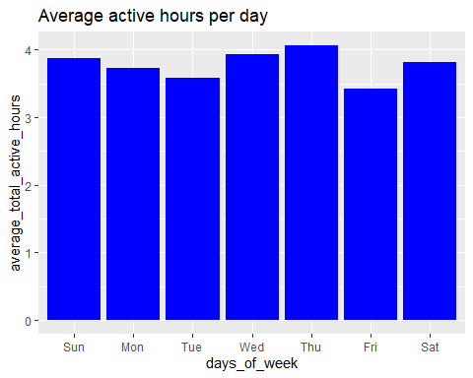

daily_activity %>%  
 group_by(days_of_week) %>%  
 ggplot(aes(x = days_of_week, y = total_steps)) +  
 geom_col(fill = "blue") +  
 labs(title = "Total steps per day")

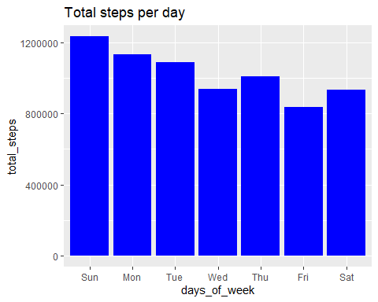

daily_activity %>%  
 group_by(days_of_week) %>%  
 ggplot(aes(x = days_of_week, y = total_active_hours)) +  
 geom_col(fill = "blue") +  
 labs(title = "Total active hours per day")

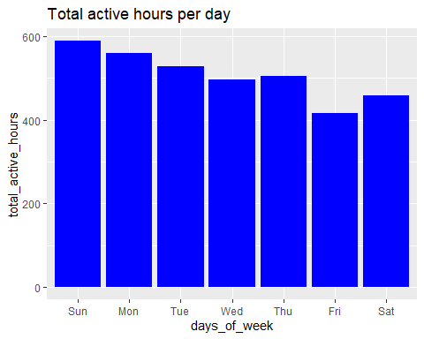

daily_activity %>%  
 group_by(days_of_week) %>%  
 ggplot(aes(x = days_of_week, y = calories)) +  
 geom_col(fill = "blue") +  
 labs(title = "Total calories burned per day")

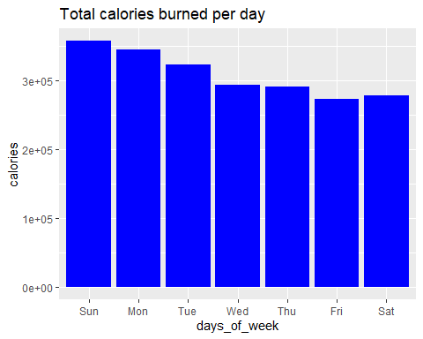

avg_int_by_hour <- hourly_intensities %>%  
 group_by(Time) %>%  
 drop_na() %>%  
 summarise(average_total_intensity = mean(total_intensity))  
  
ggplot(avg_int_by_hour, aes(x = Time, y = average_total_intensity)) +  
 geom_histogram(stat = "identity", fill = "dark blue") +  
 theme(axis.text.x = element_text(angle = 270)) +  
 labs(title = "Time when there are most intensisies")

## Warning in geom_histogram(stat = "identity", fill = "dark blue"): Ignoring  
## unknown parameters: `binwidth`, `bins`, and `pad`

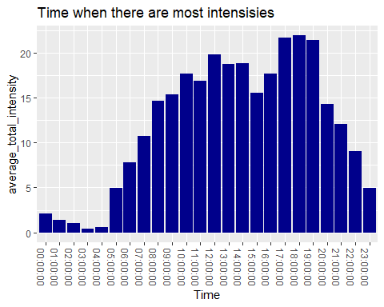

aggregate(daily_activity$total_active_hours, list(daily_activity$days_of_week), FUN = sum)

## Group.1 x  
## 1 Sun 589  
## 2 Mon 559  
## 3 Tue 528  
## 4 Wed 496  
## 5 Thu 504  
## 6 Fri 415  
## 7 Sat 458

daily_activity %>%  
 group_by(days_of_week) %>%  
 summarise(average_sedentary_minutes = mean(sedentary_minutes)) %>%  
 ggplot(aes(x = days_of_week, y = average_sedentary_minutes)) +  
 geom_col(fill = "blue") +  
 labs(title = "Average time spent sitting per days")

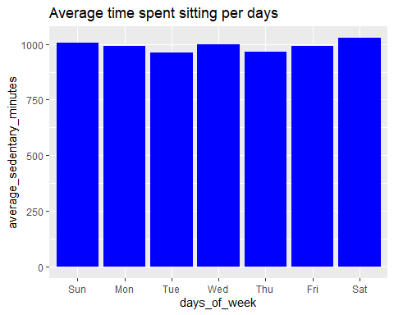 ### Correlations:

cor(daily_activity$total_steps, daily_activity$calories)

## [1] 0.5915681

cor(daily_activity$total_active_hours, daily_activity$calories)

## [1] 0.4669456

cor(daily_activity$very_active_minutes, daily_activity$calories)

## [1] 0.6158383

cor(daily_activity$sedentary_minutes, daily_activity$calories)

## [1] -0.106973

ggplot(daily_activity, aes(x = total_steps, y = calories)) + geom_smooth() + geom_point(color = "maroon")

## `geom_smooth()` using method = 'loess' and formula = 'y ~ x'

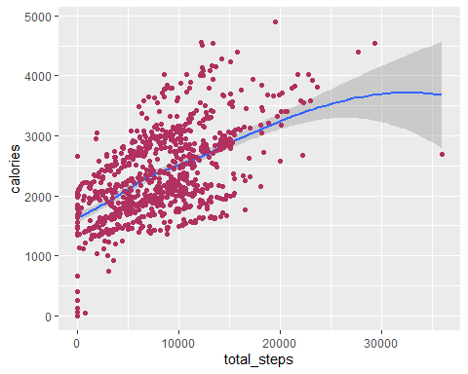

ggplot(daily_activity, aes(x = total_active_hours, y = calories)) + geom_jitter(color = "maroon") + geom_smooth() + labs(title = "Correlations between calories burned and active hours")

## `geom_smooth()` using method = 'loess' and formula = 'y ~ x'

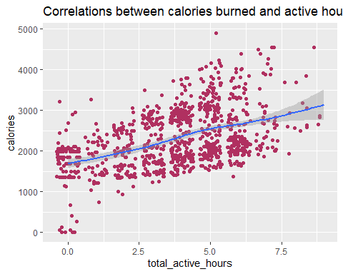

ggplot(daily_activity, aes(x = very_active_minutes, y = calories)) + geom_jitter(color = "maroon") + geom_smooth() + labs(title = "Very active minutes vs. calories burn")

## `geom_smooth()` using method = 'loess' and formula = 'y ~ x'

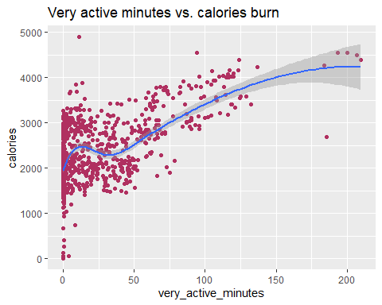

ggplot(daily_activity, aes(x = lightly_active_minutes, y = calories)) + geom_jitter(color = "maroon") + geom_smooth() + labs(title = "Light active minutes vs. calories burn ")

## `geom_smooth()` using method = 'loess' and formula = 'y ~ x'

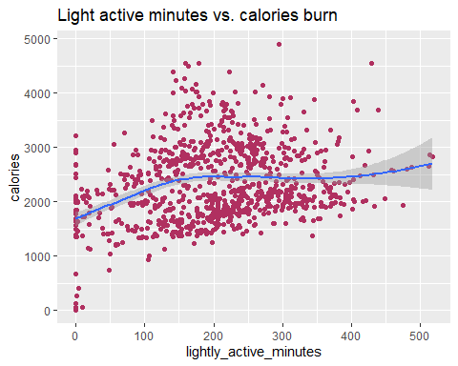

ggplot(daily_activity, aes(x = sedentary_minutes, y = calories)) + geom_jitter(color = "maroon") + geom_smooth() + labs(title = "Correlations between calories burned and sedentary")

## `geom_smooth()` using method = 'loess' and formula = 'y ~ x'

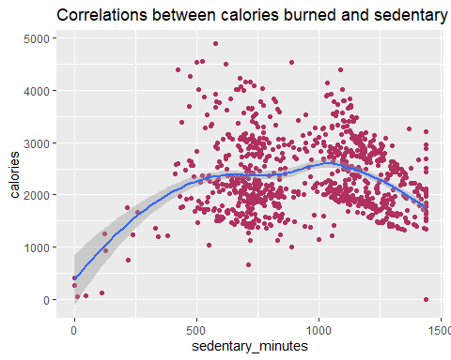

## Summary

After analyzing the plot, it seem that there are a drop off in active hour after sunday, while the average active hours are around 3-4 hours a day from the first plot we know that it mostly consist of lightly active from a quick summary that we did before it./

Also, there are a strong correlation between total steps and calories burn from the correlation test and the plot. There are correlation between active hours and calories burn, however there are only moderate since the correlation coefficient is only 0.46. The relationship between active and calories burn does get better as we look at the correlation test and plot between very active and lightly active./

### Recommendation and ideas

1. Bellabeat could have recommend workout routine through the app that let user know what workout they do for each day. From a personal experience, when I first start workout it very demotivating since I have no idea what to do, which in turn cause me to be lazy and not go to the gym, but after having a workout routine it give me no excuse since I have a set workout ready for me./
2. Having a notification of calories burn after a workout also motivate an individual since it show a goal that they have achieve./
3. The average sedentary is very concerning, what Bellabeat could do is have notification through there app that let user know when the sedentary time is high and recommend to do a light walk or stand up to stretch./